**Q1**. [20] **Cancer Diagnosis with One Test.**

After the lab test, the doctor has bad news and good news to a patient.

The bad news is that he tested positive(+) for a cancer and that the accuracy of test is 90% ( i.e. the probability of testing positive(+) when he does have a cancer is 0.90) while the specificity of test is 80% as is the probability of testing negative(-) when he doesn’t have a cancer. The good news is that this is a rare form of cancer, striking only 1 % of population has this type of cancer.

Using the following variables, compute the following probability.

C : the patient has a particular form of cancer or not ∈ {c, ¬c }

T1 : a lab test T1 with two possible outcomes ∈ {+, - }

+ : positive result, - : negative result.

1. [10] Compute the probability that a patient has a cancer when he has a positive test result.
2. [10] Compute the probability that a patient doesn’t have a cancer when he has a negative test result.

***Answer:***

From the question, we know:

tested positive (+) for a cancer and that the accuracy of test is 90%:

P(+|c) = 0.9

specificity of test is 80% as is the probability of testing negative (-) when he doesn’t have a cancer:

P(-|Ꞁc) = 0.8

only 1 % of population has this type of cancer

P(c) = 0.01

We can also know P(+) = P(-) = ½ = 0.5, since the probability to be positive or negative of the

cancer are equal, divided by 1.

So, (1) Compute the probability that a patient has a cancer when he has a positive test result.

Based on Bayes' theorem: P(A|B) = P(B|A) * P(A) / P(B), where A, B are events and P(B) ≠ 0.

P(c|+) = **P(+|c) * P(c) / P(+)** = 0.9 * 0.01 / 0.5 = 0.018.

(2) Compute the probability that a patient doesn’t have a cancer when he has a negative test result.

Similarly, Based on Bayes' theorem

P(Ꞁc|-) = P(-|Ꞁc) * P(Ꞁc) / p(-) = **P(-|Ꞁc) * (1-p(c)) / p(-)** = 0.8 * (1-0.01) / 0.5 = 1.584.

**Q2**. [30] **Cancer Diagnosis with Two Tests.**

In Q1, the 2nd lab test (T2) is given to the patient as well as the 1st test (T1) for a more accurate result. For the 2nd test, both its accuracy and specificity are as same as the 1st test.

1. [10] Compute the probability that he has a cancer when both test results are positive.

i.e. T1= +, T2= +.

1. [10] Compute the probability that he has a cancer when T1 = + but T2 = - .
2. [10] Compute the probability that test 2 reveals positive when test 1 gave positive result.

***Answer:***

Q2 (1) Compute the probability that he has a cancer when both test results are positive

P(c | T1 = +, T2 = +) = P(c | T1 = +) * P (c|T2 = +) = P(c|+) * P(c|+) = 0.018*0.018 = 0.000324.

(2) Compute the probability that he has a cancer when T1 = + but T2 = - .

P (c | T1 = +, T2 = -) = P(c | T1 = +) * P (c|T2 = -) =

(3) Compute the probability that test 2 reveals positive when test 1 gave positive result

P(T2 = + | T1 = +)

**Q3. [10] Bayesian Network Construction**

Suppose we want to use the diagnostic assistant to diagnose whether there is a fire in a building based on noisy sensor information and possibly conflicting explanations of what could be going on. The agent receives a report about whether everyone is leaving the building. Suppose the report sensor is noisy: It sometimes reports leaving when there is no exodus (a false positive), and it sometimes does not report when everyone is leaving (a false negative). Suppose the fire alarm going off can cause the leaving, but this is not a deterministic relationship. Either tempering or fire could affect the alarm. Fire also causes smoke to rise from the building.

***Construct the Bayesian network*** using the following Boolean variables in the following order:

* ***Tampering*** is true when there is tampering with the alarm.
* ***Fire***is true when there is a fire.
* ***Alarm*** is true when the alarm sounds.
* ***Smoke*** is true when there is smoke.
* ***Leaving*** is true if there are many people leaving the building at once.
* ***Report*** is true if there is a report given by someone of people leaving. *Repor*t is false if there is no report of leaving.

（图重画（用Word, 防止看出抄袭）

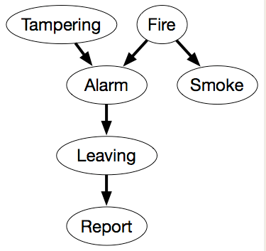

This network represents the factorization:

P(Tampering,Fire,Alarm,Smoke,Leaving,Report) = P(Tampering) ×P(Fire) ×P(Alarm|Tampering,Fire)

×P(Smoke|Fire) ×P(Leaving|Alarm) ×P(Report|Leaving).

We also must define the domain of each variable. Assume that the variables are Boolean; that is, they have domain {true,false}. We use the lower-case variant of the variable to represent the true value and use negation for the false value. Thus, for example, Tampering=true is written as tampering, and Tampering=false is written as ¬tampering.

The examples that follow assume the following conditional probabilities:

（图重画（用Word, 防止看出抄袭）

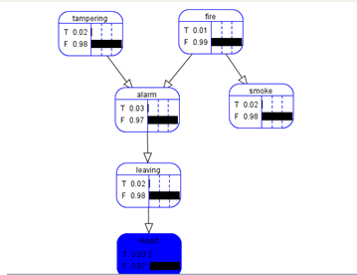

The following conditional probabilities follow from the model,

P(tampering ) = 0.02

P(fire) = 0.01

P(report ) = 0.03

P(smoke) = 0.02

P(alarm ) = 0.03

P(leaving) = 0.02

Now, observe the values by making Tampering as true

（图重画（用Word, 防止看出抄袭）

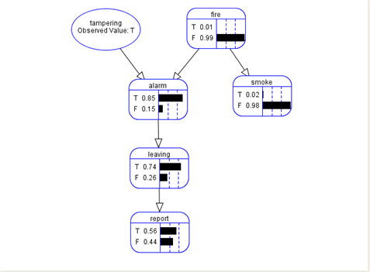

P(alarm | tampering) = 0.85

P(leaving | alarm) = 0.74

P(report | leaving) = 0.56

Let us make the fire as true along with tampering,

图重画（用Word, 防止看出抄袭）

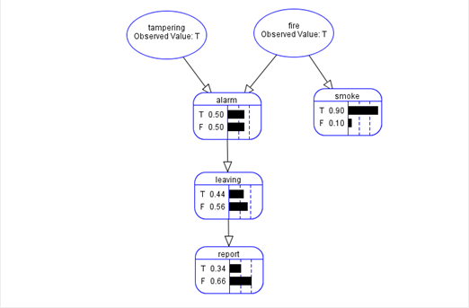

P(alarm|tampering ^ fire) = 0.50

P(leaving|alarm) = 0.44

P(report|leaving) = 0.34

As we all know that the leaving and report is depend on alarm and conditionally independent of Tampering and Smoke.To prove this let us make the alarm as false given tampering and fire

图重画（用Word, 防止看出抄袭）

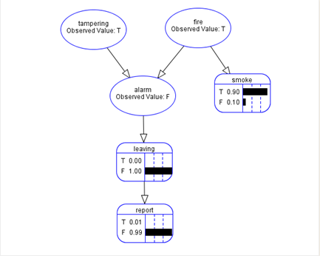

From the figure it is clear that the leaving and report is depend on alarm not on fire and tampering.By this way we can conclude with the following probability assumptions

P(tampering) = 0.02

P(fire) = 0.01

P(alarm | fire ∧tampering) = 0.5

P(alarm | fire ∧¬tampering) = 0.99

P(alarm | ¬fire ∧tampering) = 0.85

P(alarm | ¬fire ∧¬tampering) = 0.0001

P(smoke | fire ) = 0.9

P(smoke | ¬fire ) = 0.01

P(leaving | alarm) = 0.88

P(leaving | ¬alarm ) = 0.001

P(report | leaving ) = 0.75

P(report | ¬leaving ) = 0.01

**Q4.[30 pts.] Inference in Bayesian Network**

Consider the simple Bayes net below with Boolean variables:

*B = BrokeElectionLaw, I = Indicted, M = PoliticallyMotivatedProsecutor, G = FoundGuilty, J = Jailed.*



1. [10] Which of the following are asserted by the network structure? Explain.
2. P(B, I, M) = P(B)P(I)P(M).
3. P(J|G) = P(J|G,I)
4. P(M|G,B,I) = P(M|G,B,I,J)
5. [10] Calculate the value of P(*b ,I ¬m, g, j*). Show the essential steps of your computation.
6. [10] Calculate the probability that someone goes to jail given that they broke the law, have been indicated, and face a politically motivated prosecutor. Define the probability that you have to compute and show the essential computational steps.

***Answer:***

1 Which of the following are asserted by the network structure? Explain.

(a) P(B, I, M) = P(B)P(I)P(M) False, would need I ⊥⊥ B ⊥⊥ M

(b) P(J|G) = P(J|G,I)

True, J ⊥⊥ I | G.

(c) P(M|G,B,I) = P(M|G,B,I,J)

True, M ⊥⊥ J | G, B, I.

2. Calculate the value of P(b ,I, Ꞁm, g, j). Show the essential steps of your computation.

P(b ,I, Ꞁm, g, j) = P(b) P(Ꞁm) P(I|b, Ꞁm) P(g|b, I, Ꞁm)P(j|b)

3. Calculate the probability that someone goes to jail given that they broke the law, have been indicated, and face a politically motivated prosecutor. Define the probability that you have to compute and show the essential computational steps

